- Use Case Title
OTP Verification - Secure client authentication
ID: 006
Actors
• Client (User undergoing verification)
• System (Authentication Engine)
• SMS Gateway (Twilio/Nexmo)
• Admin (Fallback support)
Overall Description
Manages one-time password (OTP) generation, delivery, and validation during
registration/login to prevent fraudulent access.
Business Trigger
• Triggered at:
o New registration (post UC005)
o Password reset requests
o Suspicious login attempts
Inputs and Outputs
Inputs - Outputs
Client mobile/email - 6-digit OTP (SMS/email)
Device fingerprint - Verification success/failure log
Geolocation data - Session token (JWT)
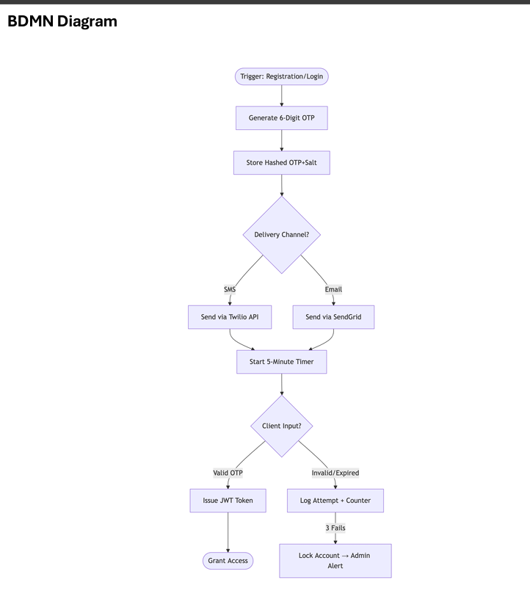
Security Specifications
1. OTP Generation:
o Cryptographically secure random bytes
o Rate-limited (1 OTP/90s per number)
2. Transmission:
o SMS: Masked sender ID (e.g., "PANVEL-V")
o Email: DKIM-signed with no-click disclaimer
3. Validation:
o HMAC-SHA256 hash comparison
Alternative Flows
• A1: Delivery Failure
o System switches channel (SMS→email) after 2min timeout
• A2: No Network
o Generates backup TOTP (Google Authenticator compatible)
Database Schema
Table: auth_otp
Field
Type
Description
request_id
UUID
hashed_code CHAR(64)
OTP session identifier
SHA-256 hashed OTP
salt
CHAR(16)
expires_at
Per-request entropy
TIMESTAMP TTL enforcement
delivery_meta JSON
Carrier/email service logs
Integration Requirements
Service Purpose
SLA
Twilio
SMS delivery
Redis
<4s latency
OTP caching
Splunk Fraud analytics Real-time alerts
<1ms read/write
UX Considerations
1. Client Side:
o Auto-read SMS OTP on Android/iOS
o Copy-paste disabled for web forms
2. Admin Side:
o Visual heatmap of failed attempts
o One-click number whitelisting

- Use Case Title
Document Validation – Automated verification of client documents
ID 007
Actors
• Client (Uploads documents)
• System (AI Document Validator Module)
• Admin (Manual review if validation fails)
Overall Description
This use case describes how the platform validates client-submitted documents (e.g.,
business licenses, IDs) during onboarding using AI-powered checks for authenticity, format,
and completeness.
Business Trigger / Frequency
• Trigger: Client uploads documents during registration or profile updates.
• Frequency: Per client onboarding (1–5 documents per session).
Inputs and Outputs
Inputs
Client-uploaded documents (PDF, JPG, PNG)
Outputs
Validation status
(Approved/Rejected)
Predefined document requirements (e.g., file size,
format)
Flagged discrepancies (e.g., expired
ID)
Admin override (if applicable)
Audit log entry
Use Case Description (Step-by-Step)
2. System:
o Scans documents for format compliance (e.g., file type, resolution).
o Extracts text/data using OCR (e.g., expiry dates, registration numbers).
o Cross-checks extracted data against predefined rules (e.g., "Business license
must be valid for 6+ months").
3. System:
o If valid: Marks documents as "Approved" and grants dashboard access.
o If invalid: Flags issues (e.g., "ID expired") and notifies the client to re-upload.
4. Admin (Alternative Flow A1): Manually reviews disputed documents and overrides the
AI decision if needed.
Alternative Flows
• A1: Ambiguous Document
o System routes to an admin queue for manual review; client receives a pending
status notification.
• A2: Repeated Failures
o After 3 rejections, system locks the account and triggers a chatbot-assisted
resolution flow.
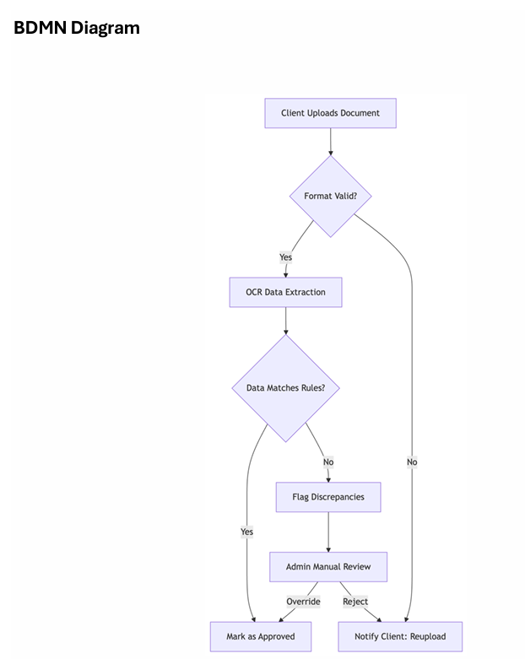

- Use Case Title
Export Engine – Automated report generation and data distribution
ID. 032
Actors
• System (Report generator)
• User (Employee/Client/Admin)
• Scheduler (Time-based triggers)
• API Consumer (External systems)
Overall Description
This use case enables one-click export of analytics (from UC030), campaign data, and
strategy documents in multiple formats, with automated distribution to stakeholders via
integrated channels (UC012 WhatsApp, email, cloud storage).
Business Trigger / Frequency
• Trigger:
o Manual export request
o Scheduled report time (daily/weekly/monthly)
o Threshold alerts (e.g., 20% ROAS drop)
• Frequency: 50-200 exports daily
Inputs and Outputs
Inputs
Outputs
UC030 analytics data PDF/CSV/PPT files
User-defined filters
Distribution list
Shared links (GDrive, OneDrive)
Email/WhatsApp confirmations
Use Case Description (Step-by-Step)
1. User: In UC011 (Employee) or UC010 (Client):
o Selects data range/filters
o Chooses format (PDF dashboard, raw CSV)
o Sets delivery method (email, WhatsApp, API)
2. System:
o Generates file with:
▪ Branded templates (UC025)
▪ Dynamic visualizations
▪ Password protection for sensitive data
3. Distributor:
o Sends via:
▪ UC012 for WhatsApp delivery
▪ SMTP for email
▪ Direct API push to BI tools
4. Confirmation:
o Logs delivery status
o Retries failed attempts (3x)
Alternative Flows
• A1: Large Data Export
Splits into multi-part ZIP files >500MB
• A2: Realtime API Feed
Streams JSON instead of file creation.

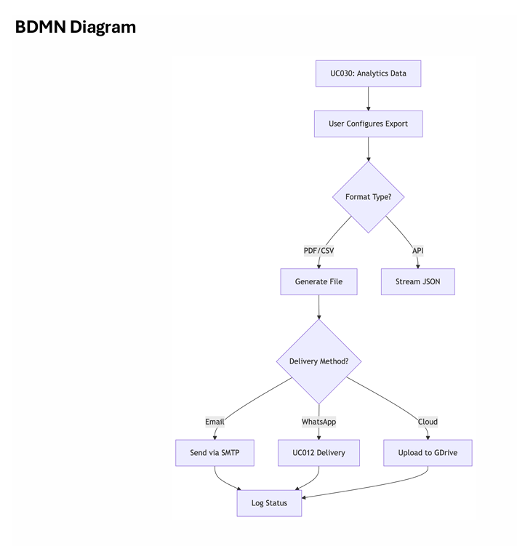

Notes
• Compliance: GDPR data minimization in exports
• Performance: Handles 10K+ rows in <30 seconds
• Security: AES-256 encryption for all files
Related Requirements
Type
ID
Description
Functional
16.1 Multi-format export engine
Non-Functional 16.4 99.9% delivery success rate
Security
3.12 Automatic file expiration (30d)
Screen Fields / UI Elements
Section
Field
Type
Validation
Export Builder Data Range
Delivery
Calendar Max 365-day span
Recipient Picker Tag input Verifies email/phone formats
Database Tables
Table: export_jobs
Field
Type
Description
job_id
UUID
file_size
With creation timestamp
INT
In megabytes
recipients
JSON
expiry_date DATETIME Auto-delete trigger
Encrypted contact list
Assumptions
1. UC030 data is pre-validated for accuracy
2. Cloud storage credentials remain valid
3. Users have 10GB minimum storage quota

ID. 022
Actors
• System (Backlink analysis engine)
• Employee (SEO specialist)
• Admin (Threshold configurator)
• AI Assistant (UC033 for outreach drafting)
Overall Description
This use case describes how the platform identifies high-value backlink opportunities,
prioritizes them based on domain authority and relevance, and automates outreach through
integrated channels (connecting to UC021 SEO Audit for target analysis and UC012
WhatsApp Automation for communication).
Business Trigger / Frequency
• Trigger:
o Weekly automated scan (scheduled)
o Immediate when new content publishes (from UC015)
• Frequency: 20-50 qualified opportunities weekly per client
•
Inputs and Outputs
Inputs
Outputs
Ahrefs/Moz API data
Client content library (UC015) Personalized outreach drafts
Prioritized backlink targets
Competitor backlink profiles
Outreach status tracking
Use Case Description (Step-by-Step)
1. System:
o Scans for opportunities using:
▪ Broken link building targets
▪ Resource page gaps
▪ Competitor backlink analysis
2. AI Engine:
o Scores targets by:
▪ Domain Authority (20-100)
▪ Topic relevance (NLP analysis)
▪ Historical response rate
3. Outreach Automation:
o UC033 drafts personalized emails/LinkedIn messages
o UC012 handles WhatsApp outreach when preferred
+91-484-2379500
consultant@calim.ai
81
No. 4/461,2nd Floor,
Suite no. 1659,Thrikkakara,
Ernakulam, Kerala 682021
CALIMPIQ0001
o Tracks responses in CRM
4. Employee:
o Reviews top opportunities in UC011
o Adjusts outreach strategy based on performance
Alternative Flows
• A1: High-Value Manual Outreach
Flags "Authority 80+" targets for human-led negotiation
• A2: Negative Response
Auto-removes domain from future campaigns
Notes
• Compliance: Adheres to Google's link scheme guidelines
• Integration: Ahrefs API, LinkedIn Sales Navigator
• Success Rate: 35% acceptance for personalized outreach
Related Requirements
Type
ID
Description
Functional
13.1 Authority-based target filtering
Non-Functional 13.3 Process 10K+ pages/hour
Compliance
4.7
Anti-spam safeguards
Screen Fields / UI Elements
Section
Field
Type
Target List
DA Score
Validation
Outreach Draft Tone Selector Dropdown
Color-coded badge Red <30, Green >70
["Formal","Friendly"]
Database Tables
Table: backlink_campaigns
Field
Type
Description
target_url
outreach_date
VARCHAR(255) MD5 hashed
DATETIME
response_status ENUM
Timezone-aware
["Pending","Accepted","Rejected"]
Assumptions
1. Minimum 50% target domains have public contact info
2. Employees review auto-discarded targets weekly
3. UC033 maintains human-like writing quality

Use Case Title
Lead Qualifier – AI-driven prospect scoring
ID: 034
Actors
• System (AI Scoring Engine)
• Employee (Sales Rep)
+91-484-2379500
consultant@calim.ai
117
No. 4/461,2nd Floor,
Suite no. 1659,Thrikkakara,
Ernakulam, Kerala 682021
CALIMPIQ0001
• Client (Business Owner)
• CRM (HubSpot/Salesforce)
Overall Description
Automatically scores inbound leads (from UC012/013) using behavioral data and
firmographic signals to prioritize sales outreach. Integrates with CRMs for instant lead routing.
Business Trigger
• Trigger: New lead capture (form submit/chatbot)
• Frequency: Real-time per lead
Scoring Model
Factor
Weight Data Source
Engagement Level 30%
Page views/email opens
Firmographic Fit
25%
Industry/revenue size
Intent Signals
20%
Social Proof
Content downloads/pricing page visits
15%
LinkedIn connections in common
Timing
10%
Recent funding/news mentions
python
# Sample Scoring Algorithm
lead_score = (engagement * 0.3) + (firmographic * 0.25) + (intent * 0.2) + (social * 0.15) + (timing * 0.1)

Integration Map
System
Connection Method Data Synced
Salesforce REST API
Zoominfo Webhook
Lead score + recommended action
Company revenue data
Drift
JavaScript Tag
Real-time chat history
UI Components
Element
Functionality
Lead Card
Priority Queue
Color-coded by score (Red/Yellow/Green)
Sorts by score + freshness
One-Click CRM Add Pre-populates contact record
Performance SLAs
• Scoring Time: <2 seconds per lead
• Accuracy: 85% conversion prediction at score >80
• Data Freshness: Enrichment updates hourly
Alternative Flows
• A1: Anonymous Visitor
Tracks via cookie → scores when identified
• A2: Channel Conflict
Flags leads already assigned to partners
Compliance Notes
1. GDPR-compliant data retention (30-day opt-out window)
2. Score explanation available on request (AI transparency)

